Western Winds Equine Education
Beginner Horsemanship Program
What can be expected:
- Re-enforcement of the previously learned life skills
- Confidence around horses
- A basic understanding of how the horse thinks and why they react the way they do
- Preparation to Learn to Ride
- Building relationships
- Self esteem when working in different situations
- A general awareness of the world around them

What will be taught:
- How to catch a horse
- Ground safety/Moving around horses in a corral or when tied
- Leading a horse
- Basic round penning and joining up
- Basic halter work
- Fence work
- Focus
By taking this program your child will learn the fundamentals and basics of working with a horse on the ground. Working in a round pen and arena setting we teach how to move the horses’ feet and make decisions as to where we want them to go, in what direction and how fast. Controlling the feet of the horse also controls its mind; they are always thinking about what and why they are doing something. Horses work on a ‘Pressure and Release’ format. If pressure is applied they will learn to seek release from it, causing them to find the release and comfort. This is the case for both good and bad behavior, therefore it is important to have a participant understand how to instruct a horse to do something to get the desired result in a safe and effective manner.
It is important to learn these steps for a better knowledge of safety while working with a horse and awareness of what is going on around you. By being aware you can learn to take appropriate measures to avoid injury and know what to do if a hazardous situation should arise. This builds confidence not only on the ground but also when you are riding; transferring the awareness and safety skills previously learned.
By learning these skills before riding, you are setting your child up for success with a higher confidence and self-esteem and the knowledge that they understand how a horse thinks to a beginner level. Once sitting on a horse, the rider must be able to make quick, smooth decisions that affect the horse in a positive way. Learning to take the lead and appropriate assertiveness is what riding is all about plus having fun!
Your child will progress at their own pace based on their ability, skill and determination. No child will be allowed to ride until all lessons are thoroughly learned and adhered by. Any instruction not followed for lack of a good attitude, the child will be asked to leave for the day and return with a positive learning attitude. This is for both the participants and the horses’ safety.

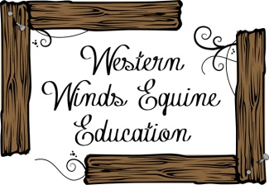
Learning to take the Lead; One Step at a Time

