Western Winds Equine Education
Learn to Ride Program
What can be expected:
- A new found freedom and confidence
- Self-esteem
- Opportunities to make decisions
- A bonding relationship with horses and people
- A fun outdoor activity to share with friends
- Basic understanding of trail riding etiquette
- Knowledge of safe riding procedures
- Lasting memories!
What will be taught:
- Proper saddling and bridling technique
- Safe and proper mounting and dismounting
- Posture in the saddle
- Giving positive direction to the horse
- Safe arena and trail riding procedures
- Having focus while riding

Riding is an excellent way to get out and enjoy the outdoors whether as an individual or in a group. By learning safe and effective saddling, mounting and riding procedures, you can reduce your risk for injury or runaways! After completing the Beginner Horsemanship Program your child will have the knowledge of how to safely interact and direct a horse from the ground. The ‘Pressure and Release’ format horses understand on the ground is the same for when being rode. By having the on-the-ground understanding of pressure and release, we transfer that knowledge to riding. Focus is a key factor to directing your horse to go where you want it to. A horse needs a good leader and a good leader needs to be assertive in a positive manner to direct it to the appropriate pattern or path.
This program will teach your child how to ride a horse confidently and safely in both an arena and trail setting. Awareness of other horses, people and obstacles is important to the success of each ride. We will provide your child with the skills to know what to do if a hazardous situation occurs and what safety measures you can do to prevent runaways.

This program will mirror your commitment. The more practice you get, the faster your child will improve. If, at any time, during a lesson a participant acts in an unsafe manner or does not adhere to direction, they will be asked to dismount and leave for the day and return with a positive learning attitude. Safety is our #1 priority when riding and it doesn’t matter what the circumstance, given instructions MUST be followed.

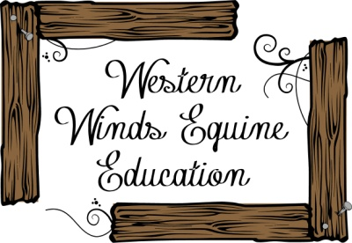
Learning to take the Lead; One Step at a Time

